Blue Ocean Student Entrepreneur Competition Empowers Next Generation of Innovators

Top high school students from around the world recognized for their innovative blue ocean business ideas

May 8, 2025

The Blue Ocean Student Entrepreneur Competition is excited to announce the winners of the 2025 competition. With participation from 12,784 students representing 6000+ schools from 163 countries and 48 US states in 2025, the world’s largest virtual entrepreneurship competition for high school students showcases the most innovative blue ocean ideas to solve the world’s most pressing problems.

Global Awards

1st Place

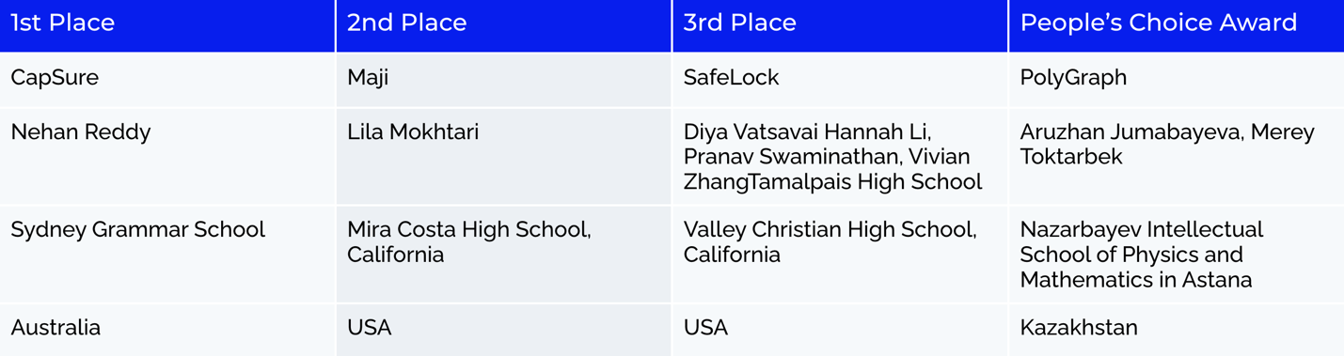

Regional Awards

North America

1st Place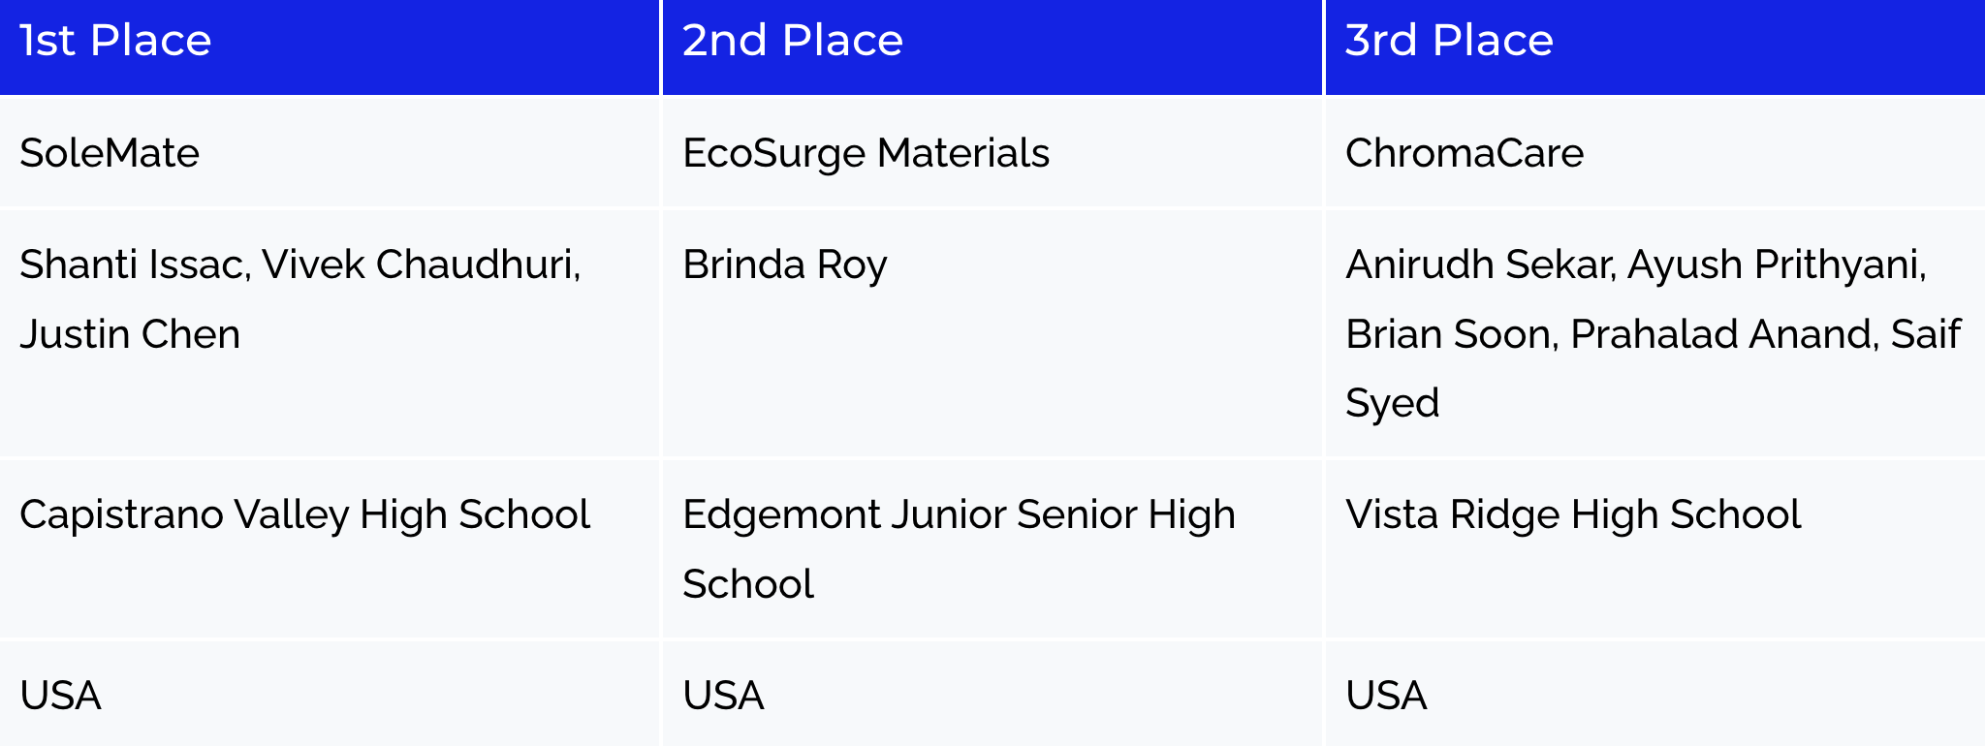

Europe

1st Place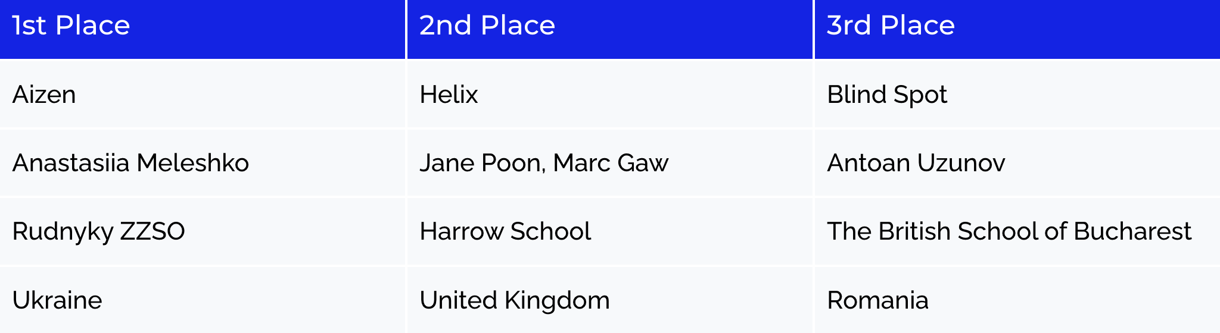

Latin America

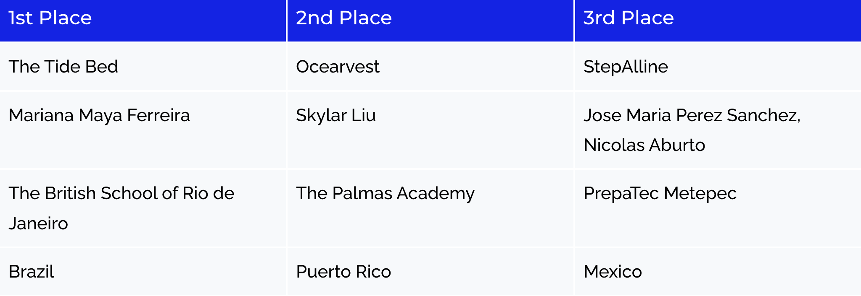

Asia

1st Place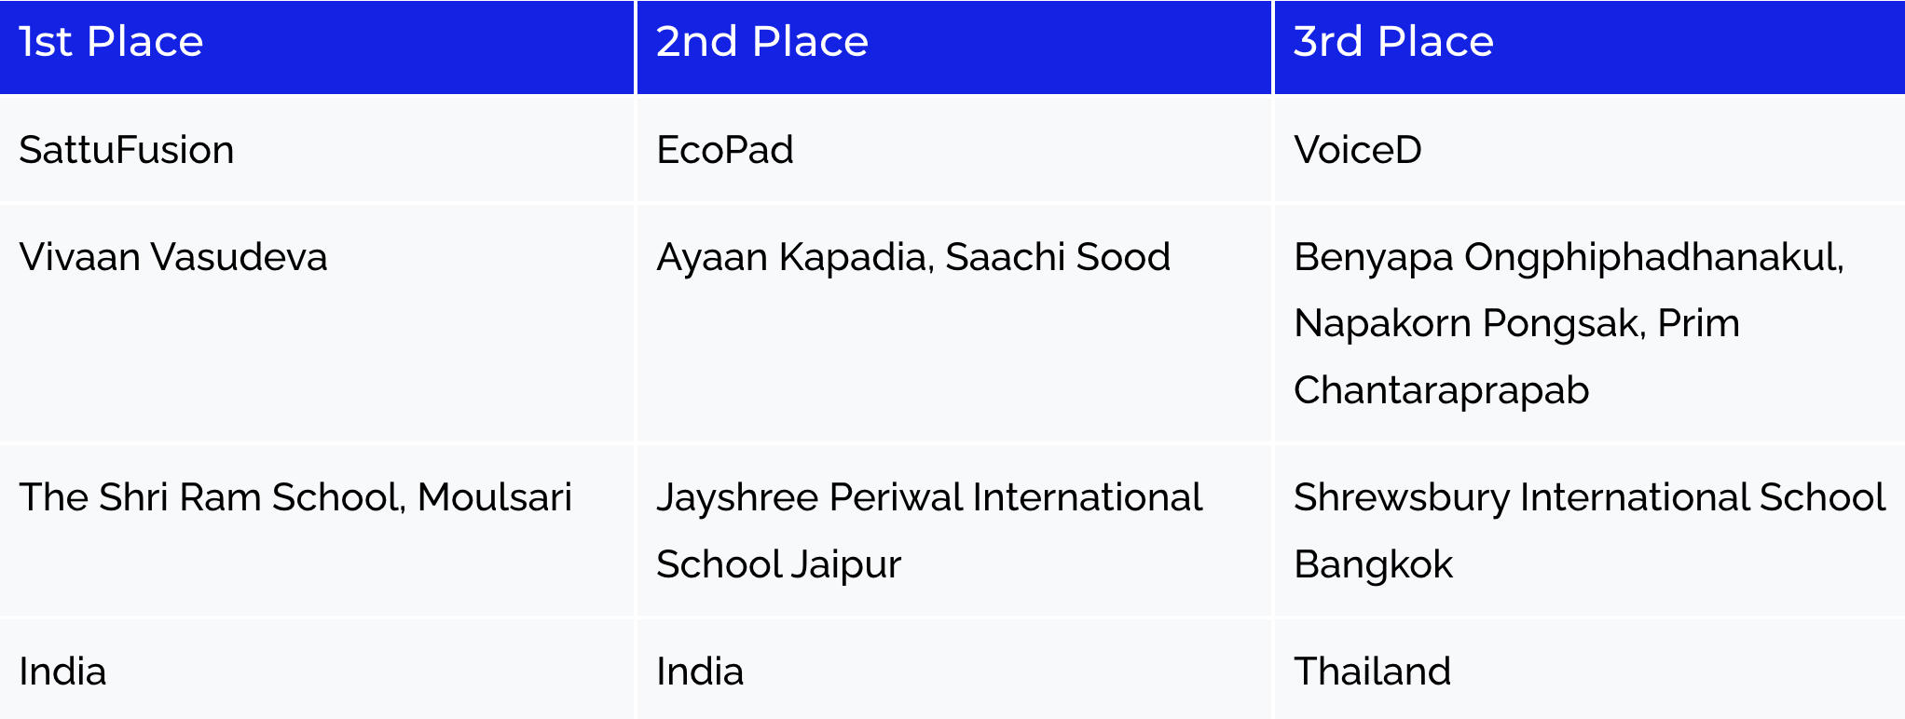

Africa

1st Place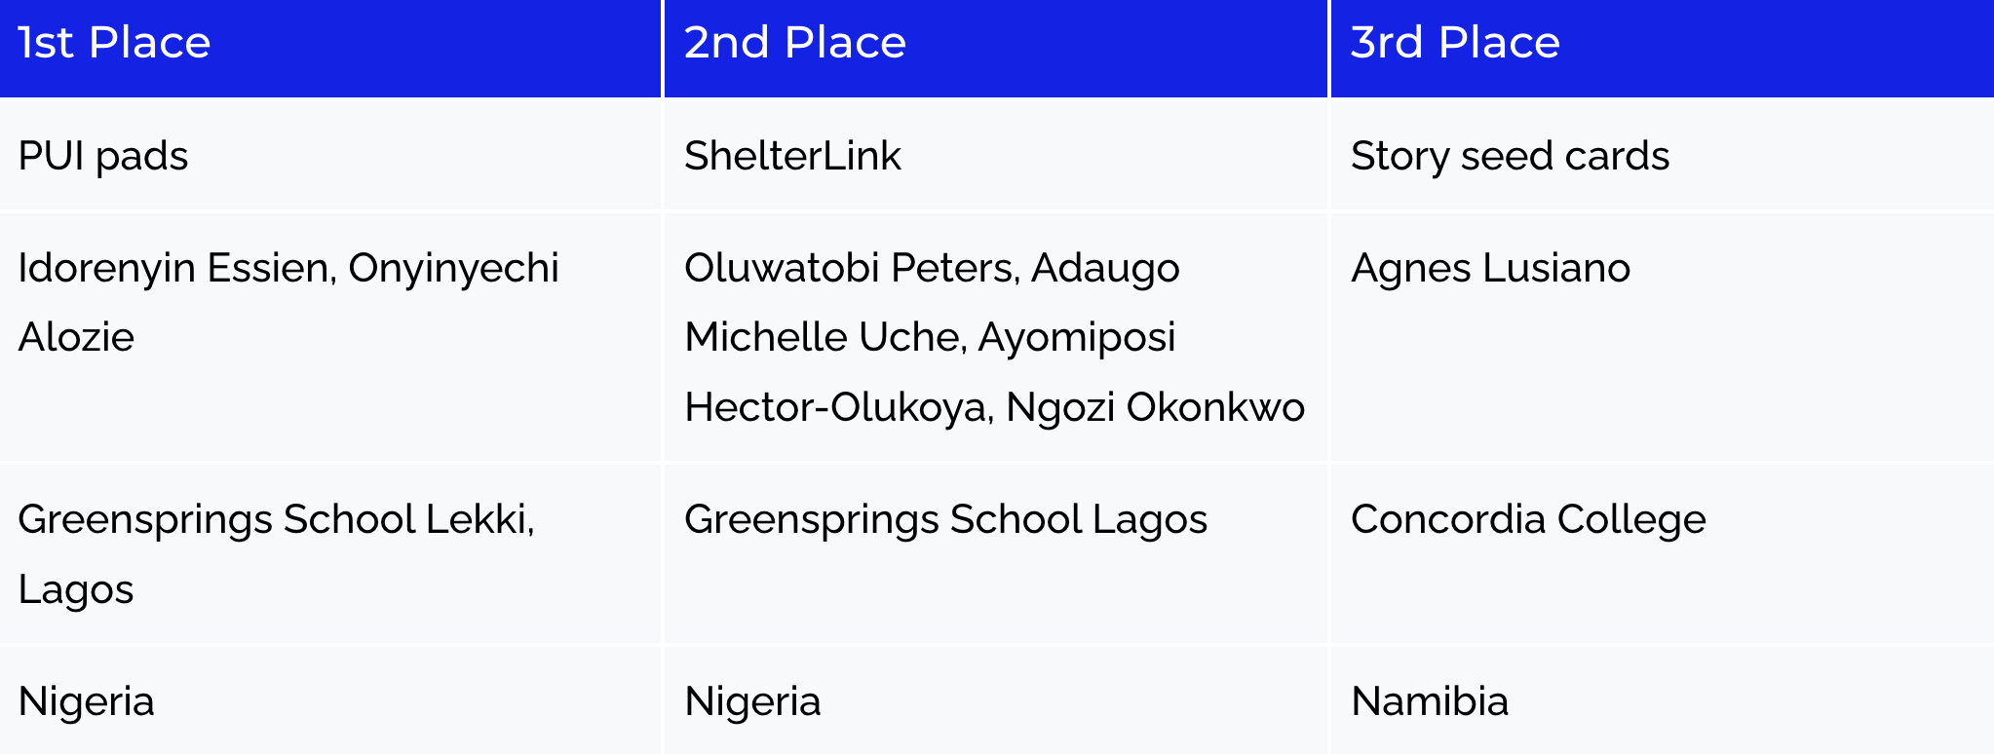

Middle East

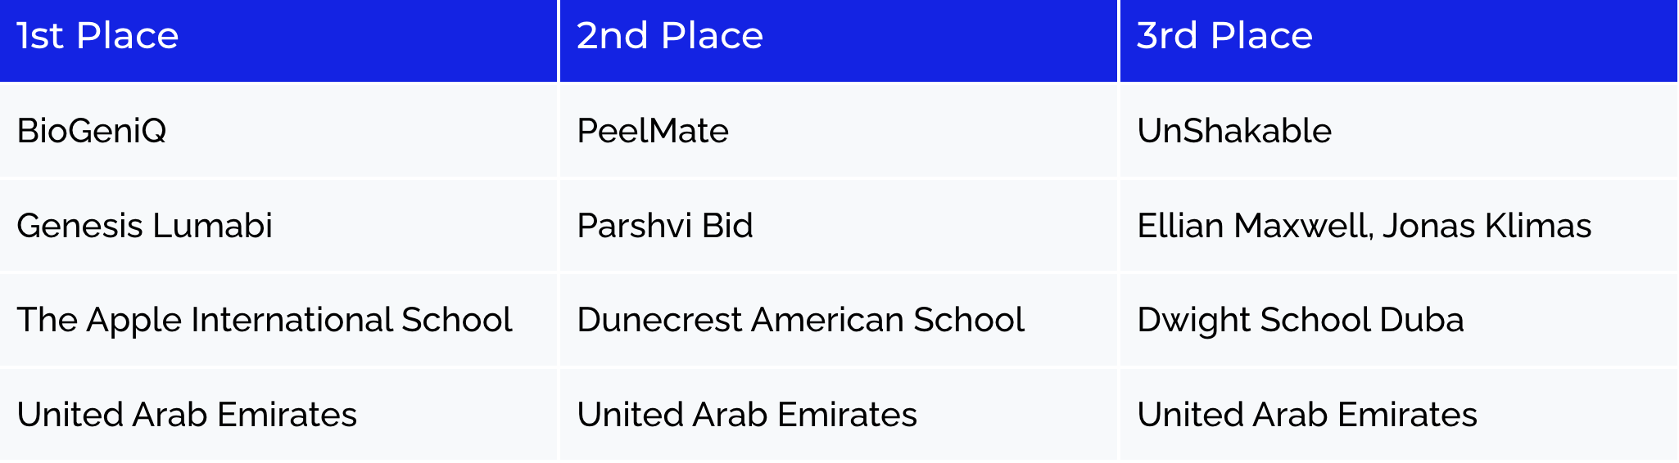

Oceania

1st Place

The World’s Largest Virtual Entrepreneurship Competition for High School Students

Inspired by Chan Kim and Renée Mauborgne’s Blue Ocean Strategy and the blue ocean way of thinking, the Blue Ocean Student Entrepreneur Competition was founded in 2014 by Nicholas Benavides, a young budding high school entrepreneur, with the mission to prepare high school students for the real world of entrepreneurship and empower them to create blue ocean businesses.

The first edition of the Blue Ocean Student Entrepreneur Competition in 2014 was at the county level, which then quickly expanded to state, and then the countrywide competition. Today it has become the largest and the most prestigious virtual entrepreneurship competition providing high school students an opportunity to compete at the global level. Participation is 100% free for all students.
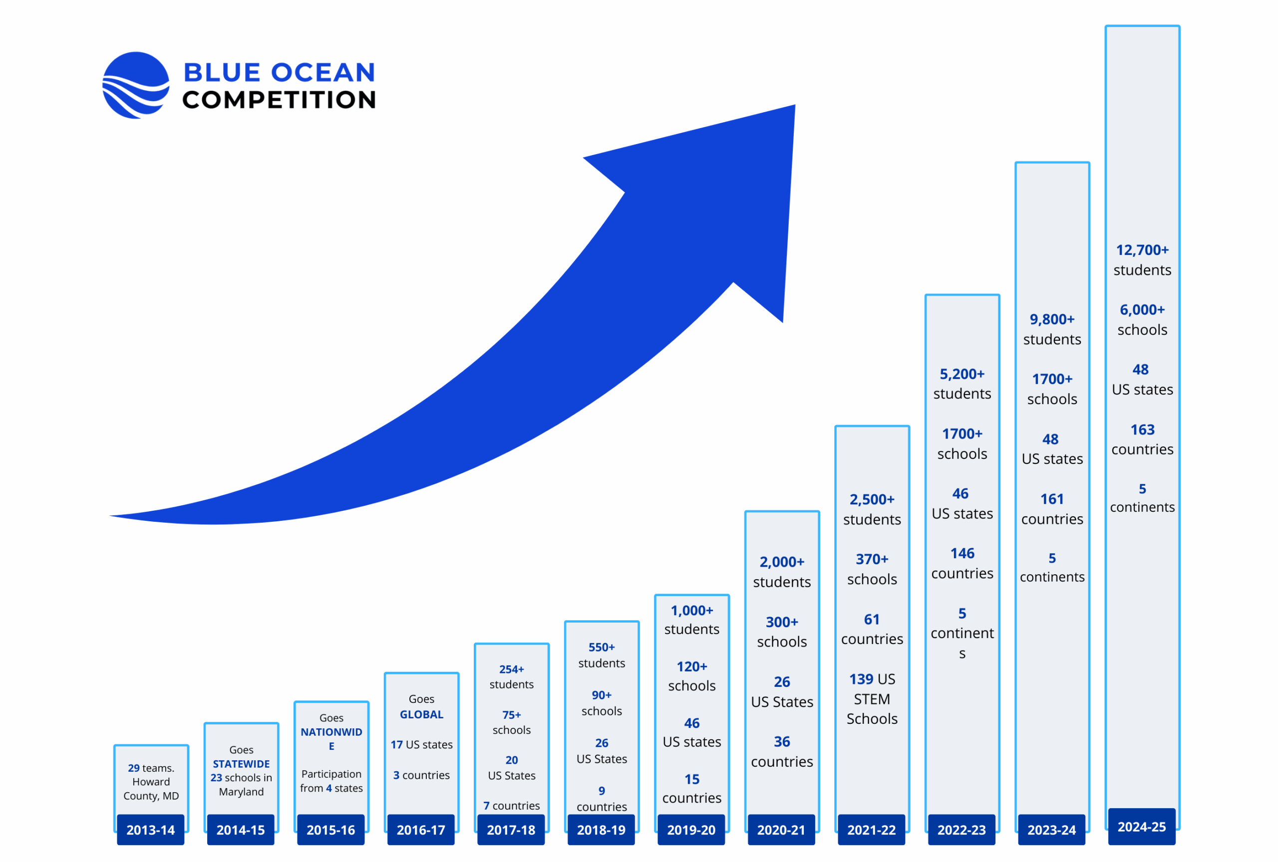

Blue Ocean Student Entrepreneurs Corp, the non-profit running the competition also recognizes and awards outstanding educators and schools for their significant contribution to preparing high school students for the real world of entrepreneurship.

Top 5 Schools with Most Submissions – 2025

South Brunswick High School
New Jersey, USA

Ward Melville High School
New York, USA

Chantily High School
Virginia, USA

Munster High School
Indiana, USA

Jayshree Periwal International School
India

School with Most Pitches in the Top 100 – 2025

Cupertino High School, California, US

Blue Ocean Teacher Champions – 2025
We are proud to recognize our 2025 Blue Ocean Teacher Champions for their outstanding commitment to guiding and inspiring the next generation of innovators. Their dedication played a key role in this year’s record-breaking competition. In recognition of his exceptional mentorship and tireless efforts to spread blue ocean entrepreneurship, Eric Sera was named the competition’s first-ever “Blue Ocean Super Teacher Champion”—a new honor celebrating extraordinary leadership in youth entrepreneurship

Blue Ocean Teacher Super Champion: Eric Sera, Munster High School, USA

Teacher champions:
- Khokon Mahmud, Glenrich International High School, Bangladesh
- Sarah McCance, Fountain Valley High School, California, USA
- Dr. Rahna K. Rathnan, JSS Private School, Dubai, UAE
- Sana Abdul Salam, Aga Khan School Garden, Pakistan
- Udo Ndidiamaka Jacinta, Regina Pacis Model Secondary School, Nigeria
- Henrik Graversen, Herningsholm Erheversskole & Gymnasier, Denmark
- Courtney Marshall, Chantilly High School, Virginia, USA
- Eman Al-Ezzi, Pax Populi, Massachusetts, USA
- Beatrize Eana T. Lamigo, Trinity University of Asia High School, Philippines
- Jassen Dowling, Holt High School, Michigan, USA
- Rasel Ahmed, Dhaka Residential Model College, Bangladesh
- John Mark E. Ludor, NU Fairview Senior High School, Philippines

Blue Ocean Student Ambassadors – 2025

The 2025 competition also marks the debut of our Blue Ocean Student Ambassadors Program, a vibrant community of high-achieving students – already 367 strong from 56 countries and growing – who champion blue ocean entrepreneurship and inspire peers while developing critical leadership skills that enhance their future prospects.

Blue Ocean Student Super Ambassador: Krethi Karthik, Ruh Continuum School, India

Student ambassadors:
- Gabdibe Wossalbe Reina Peggy
- Dinari Jayawardena
- Hugh Graves
- Md.Fatin Ishraq
- Swanith Vuppalapati
- Foday Samura
- Lauren Nyandoro
- Yuto Yamada
- Jeutsop Asnelle
- Justin Lim
- Ayaan Magoo
- Srishti Purohit
- Imaan S
- Emma Patel
- Sristy Sood
- Pijar Lintang Yanfitrio
- Mahrus Yunus
- Oviya Meenakshi
- Tendoh Katlyn Lindsy

Why the Competition matters

- 75% of new jobs in our economy are created by entrepreneurs every year.
The Blue Ocean Student Entrepreneur Competition empowers students, as young as 15 years old, to get involved in solving new and pressing programs and start businesses that create new jobs.

- 4 out 5 students can’t get a job when they graduate from college. Youth unemployment is three times higher than adult unemployment.
The Blue Ocean Student Entrepreneur Competition prepares high school students for the real world of global competition and empowers them to create jobs for themselves and others.

- 72% of high school students have considered starting their own business, yet 62% are never offered a course in entrepreneurship.

High school students are our most underutilized creative resource – if we can successfully engage their talents, we’ll unlock innovative solutions to the world’s most pressing problems.

What’s unique about the competition?

The competition challenges students to develop a 5-min pitch for a blue ocean business idea – one that stands apart from the competition; delivers innovative value at low cost; and produces win-win outcomes for everyone involved. It also encourages students to operationalize their blue ocean ideas into commercially viable businesses.
The competition gives high school students a chance to present their innovative business ideas, hone their pitching skills, earn cash prizes, and build resumes that stand out from the crowd when applying for college. Most of all, they learn how to create businesses that stand out from the competition, creating blue oceans of new market space.

Fosters a diverse and inclusive environment that promotes innovation and creativity
The Blue Ocean Student Entrepreneur Competition attracts the very best high school student entrepreneurs from all over the world. Participation is 100% free for all students, which levels the playing field and provides equal access to opportunities for aspiring entrepreneurs regardless of their socioeconomic background or nationality.

Democratizes access to a world-class education for high school students globally
The competition empowers students to think creatively and innovatively by providing them with Blue Ocean Strategy tools and frameworks to develop their ideas. To date, over 20,000 high school students have taken the Blue Ocean Mini-Course, an online course covering Blue Ocean Strategy, which is taught at nearly 3,000 universities worldwide, including the top U.S. business schools. Free access to world-class education promotes equal educational opportunities and helps bridge the divide empowering youth to create businesses of tomorrow.

The Blue Ocean Competition is a Blue Ocean in itself
The Blue Ocean Student Entrepreneur Competition effectively opened up a blue ocean of new market space in the world’s youth. Blue ocean strategy is the only leading business theory that penetrated high schools and offers a unique and innovative approach to promoting entrepreneurship among high school-aged students.

“As these high school students applied blue ocean strategies to develop solutions to some of the most pressing issues facing our planet and society, they became better prepared to make a positive difference in the world that we live in.” Ilian Mihov, Dean, INSEAD

The competition is a registered 501(c)(3) non-profit in the State of Maryland, USA.

Contact:
Blue Ocean Student Entrepreneur Competition
Zunaira Munir Ph.D. (Zee)
Executive Director, Blue Ocean Student Entrepreneurs
ED@blueoceancompetition.org
Tel: +1-858-284-959
https://blueoceancompetition.org/

