**Blue Ocean Student Entrepreneur Competition Empowers Next Generation of Innovators**

Top high school students from around the world recognized for their innovative blue ocean business ideas

April 26, 2024

The Blue Ocean Student Entrepreneur Competition is excited to announce the winners of the 2024 competition. With participation from 9,800 students from 161 countries and 48 US states in 2024, the world’s largest virtual entrepreneurship competition for high school students showcases the most innovative blue ocean ideas to solve the world’s most pressing problems.

|  |  |  |
| --- | --- | --- |
| **Global Awards - 2024** | | |
| 1st Place  Life Heat  Liam Pope-Lau  *St. Michaels University School*  CANADA | 2nd Place  **S**kyScouts  Daniel Persky, Althea Sanchez, Laurent Irakarama, Llyanna Mercado & Everette Alhambra  *Los Altos HS, Gateway Academy,*  *Rwanda Coding Academy, William Fremd HS & Everette Alhambra HS*  USA, RWANDA, PHILIPPINES | 3rd Place  Unofficial Wear  Lucy Mallard  *Tamalpais High School*  USA |

|  |  |  |
| --- | --- | --- |
| **Regional Awards – 2024** | | |
| **NORTH AMERICA** | | |
| 1st Place  FlexShlef  Sara Jankovic, Alicia Zhu,  Ishana Kumar, Daniel Pantchev  *Horace Greeley High School*  USA | 2nd Place  ShowerSaver  Sasha Ovalle  *Village Christian School*  USA | 3rd Place  ProtoCall  Cayden Pasion  *Westview High School*  USA |
| **EUROPE** | | |
| 1st Place  Fusion CoLiving  Nina Basta  *VIII PALO School*  POLAND | 2nd Place  BugBowl  Nicklas Bach, Jonas Løntoft  *Herningsholm Erhvervsskole*  DENMARK | 3rd Place  PlayBeyondBarriers  Akos Vida & Peter Sifter  *Kórösi Coma Sándor & Dunakeszi  Miklós Gimnázium*  HUNGARY |
| **LATIN AMERICA** | | |
| 1st Place  EcoPet3D  Vicenzo Vecchio  *Carmelo No1 David Bonjour HS*  URUGUAY | 2nd Place  ComparteAlgeria  Luis Diaz  *International School of Panama*  PANAMA | **3RD Place**  Concrete-Z  Guilherme Neves, Julie Essoudry  *Colegio Bandeirantes*  BRAZIL |
| **ASIA & OCEANIA** | | |
| 1st Place  ExoLimb  Guanxi Wang  *Experimental High School Beijing*  CHINA | 2nd Place  Waste Fellows  Santusht Narula, Aryan Niranjan, Sanoj Nair, Adharsh Srinivasan  *Raffles Institution*  SINGAPORE | 3rd Place  Somnia  Raajvir Vijay  International School Bangalore, INDIA |
| **AFRICA** | | |
| 1st Place  Echo  Godfrey Jr. Nembaware, Promise Mufari, Praise Singano, Patience Mungwari, Calvin Dube  *STAR Leadership Academy*  ZIMBABWE | 2nd Place  AdMa  Simone Kamupinya, Faith Kwedyo, Tanaka Makoni, Nokutenda Dzobo, Nicole Phiri  *Harare International School*  ZIMBABWE | 3rd Place  Sensory Room Without Room  Rahma Wael, Basmala Khaled  *Obour STEM School*  EGYPT |
| **MIDDLE EAST** | | |
| 1st Place  Neuroture  Rome Olivier Farardo, Andrea Pabona, Lana Sveltana Stankovic  *The Apple International School*  DUBAI, UAE | 2nd Place  EcoBuddies  Hala Ghamrawi  *Al Isla High School*  LEBENON | 3rd Place  YouDrive  Abdul Raafay,  *Lahore Grammar School*  PAKISTAN |

**The World’s Largest Virtual Entrepreneurship Competition for High School Students**

The Blue Ocean Student Entrepreneur Competition was founded in 2014 by Nicholas Benavides, a young budding high school entrepreneur inspired by Chan Kim and Renée Mauborgne’s *Blue Ocean Strategy* and the blue ocean way of thinking with the mission to prepare high school students for the real world of entrepreneurship and empower them to create blue ocean businesses. The first edition of the Blue Ocean Student Entrepreneur Competition in 2014 was at the county level, which then quickly expanded to state, and then the countrywide competition. Today it has become the largest and the most prestigious virtual entrepreneurship competition providing high school students an opportunity to compete at the global level. Participation is 100% free for all students.

**Remarkable growth and expansion in just a decade**

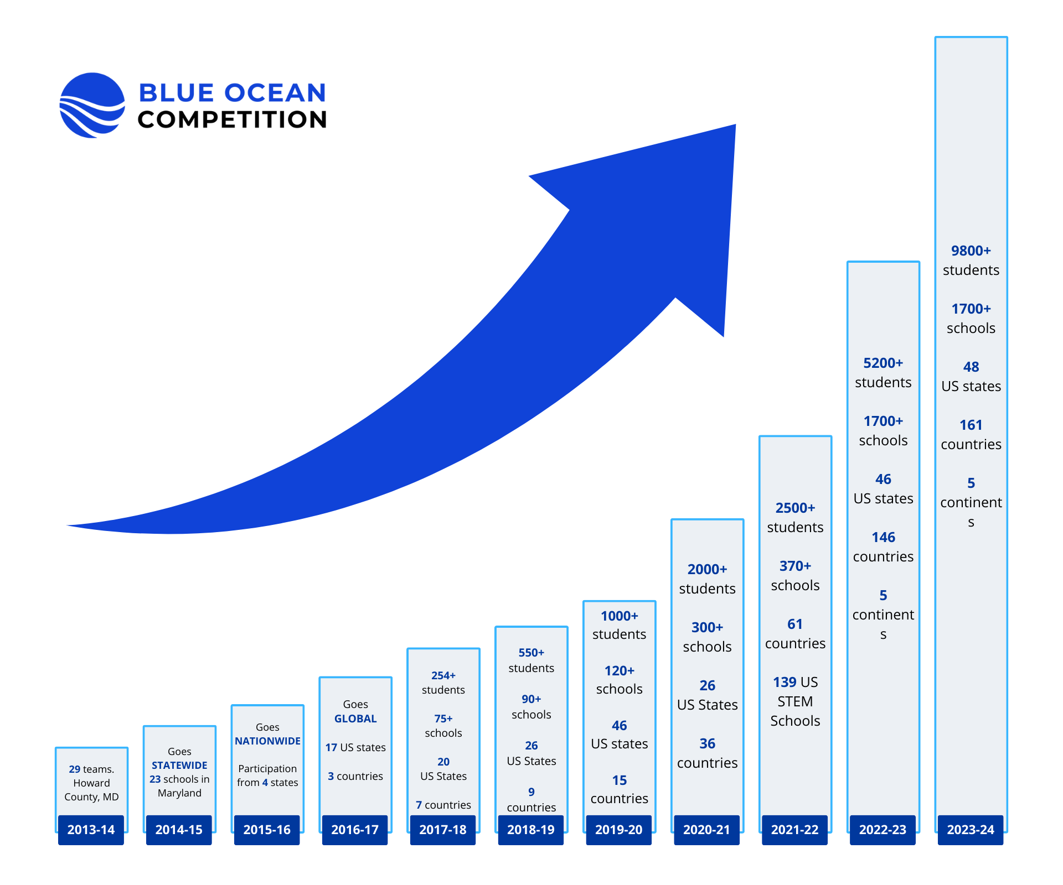

Blue Ocean Student Entrepreneurs Corp, the non-profit running the competition also recognizes and awards outstanding educators and schools for their significant contribution to preparing high school students for the real world of entrepreneurship.

|  |  |  |  |  |
| --- | --- | --- | --- | --- |
| **Top 5 Schools with Most Submissions - 2024** | | | | |
| Ward Melville  High School  New York, USA  29 Teams | South Brunswick High School  New Jersey, USA  29 Teams | Miami Palmetto Senior High School  Florida, USA  29 Teams | Thomas Jefferson HS for Science & Tech  Virginia USA  16 Teams | University of Toronto Schools  Canada  12 Teams |

|  |
| --- |
| **School with Most Pitches that Made it to Top 100 - 2025** |
| Dublin High School, California USA |

|  |  |  |  |  |  |
| --- | --- | --- | --- | --- | --- |
| **Blue Ocean Teacher Champions - 2024** | | | | | |
| Khokon Mahmud  *DPS STS School*  BANGLADESH | Allwyn Bryner  *International School*  PANAMA | Tendai Magaya  *Mattayom WatMai*  *KrongThong*  THAILAND | Henrik Graversen  *Herningsholm*  *Erhvervsskole Gymnasier*  DENMARK | Eric Sera  *Munster HS Indiana*  USA | Sana Abdul Salam  *Aga Khan School*  PAKISTAN |

**Why the Competition matters**

* 75% of new jobs in our economy are created by entrepreneurs every year.

The Blue Ocean Student Entrepreneur Competition empowers students, as young as 15 years old, to get involved in solving new and pressing programs and start businesses that create new jobs.

* 4 out 5 students can’t get a job when they graduate from college. Youth unemployment is three times higher than adult unemployment.

The Blue Ocean Student Entrepreneur Competition prepares high school students for the real world of global competition and empowers them to create jobs for themselves and others.

* 72% of high school students have considered starting their own business, yet 62% are never offered a course in entrepreneurship.

High school students are our most underutilized creative resource – if we can successfully engage their talents, we’ll unlock innovative solutions to the world’s most pressing problems.

**What’s unique about the competition?**

The competition challenges students to develop a 5-min pitch for a blue ocean business idea – one that stands apart from the competition; delivers innovative value at low cost; and produces win-win outcomes for everyone involved. It also encourages students to operationalize their blue ocean ideas into commercially viable businesses.

The competition gives high school students a chance to present their innovative business ideas, hone their pitching skills, earn cash prizes, and build resumes that stand out from the crowd when applying for college. Most of all, they learn how to create businesses that stand out from the competition, creating blue oceans of new market space.

**Fosters a diverse and inclusive environment that promotes innovation and creativity**

The Blue Ocean Student Entrepreneur Competition attracts the very best high school student entrepreneurs from all over the world. Participation is 100% free for all students, which levels the playing field and provides equal access to opportunities for aspiring entrepreneurs regardless of their socioeconomic background or nationality.

**Democratizes access to a world-class education for high school students globally**

The competition empowers students to think creatively and innovatively by providing them with Blue Ocean Strategy tools and frameworks to develop their ideas. In just two years, over 4,400 high school students have taken the Blue Ocean Mini-Course, an online course covering Blue Ocean Strategy, which is taught at nearly 3,000 universities worldwide, including the top U.S. business schools. Free access to world-class education promotes equal educational opportunities and helps bridge the divide empowering youth to create businesses of tomorrow.

**The Blue Ocean Competition is a Blue Ocean in itself**

The Blue Ocean Student Entrepreneur Competition effectively opened up a blue ocean of new market space in the world's youth. Blue ocean strategy is the only leading business theory that penetrated high schools and offers a unique and innovative approach to promoting entrepreneurship among high school-aged students.

“As these high school students applied blue ocean strategies to develop solutions to some of the most pressing issues facing our planet and society, they became better prepared to make a positive difference in the world that we live in.” Ilian Mihov, Dean, INSEAD

The competition is a registered 501(c)(3) non-profit in the State of Maryland, USA.

Contact:

Blue Ocean Student Entrepreneur Competition

Zunaira Munir Ph.D. (Zee)

Executive Director, Blue Ocean Student Entrepreneurs

[ED@blueoceancompetition.org](mailto:ED@blueoceancompetition.org)

Tel: +1-858-284-959

<https://blueoceancompetition.org/>